# 

# 

Internship Report

KONA SOFTWARE LAB LTD.

Letter of Transmittal

Date: October 23, 2022

The Chairman

Intern Placement Office

Institute of Information Technology

Noakhali Science and Technology University

Dear Sir,

I am pleased to submit the Internship Report that you had asked for. I have been working as an Intern at ‘Kona Software Lab Ltd.(KSL)’ this semester as a part of our course, SE 4100. This report contains my experience in the company. It is my immense pleasure in presenting you this report based on my observation and experience during my internship period, starting from May 15, 2022 to September 30, 2022. During this period, I worked under the supervision of Md. Saiful Islam, Head of Technology, Kona Software Lab Ltd. I hope that the report will reflect my learning during the internship program and you will find it in order.

Sincerely yours,

Md Al Adnan

BSSE 1029

7th Semester

Bachelor of Science in Software Engineering

Institute of Information Technology

Noakhali Science and Technology University

Letter of Endorsement

To Whom It May Concern

**Subject: Approval of Report**

This letter is to clarify that all the information mentioned here is true and not confidential to the company. The projects and works mentioned in this report have had the involvement of Md Arman Hossain, BSSE-1029, Institute of Information Technology, Noakhali Science and Technology University.

I wish him all the best.

Internship Supervisor

Md. Saiful Islam

Head of Technology

Kona Software Lab Ltd.

Acknowledgement

Firstly I would like to express my gratitude to the Institute of Information Technology and the Intern Placement Office for this internship program which was undoubtedly a great experience for me.

Special love to Md. Iftekharul Alam Efat sir, Assistant Professor of  Institute of Information Technology, Noakhali Science and Technology University for giving me the opportunity to work as an intern in this organization.

I would like to thank Auhidur Rahman Sumon Sir, Assistant Professor of Institute of Information Technology, Assistant Professor, for guidance in resume writing to managing KSL for us .

I am grateful to KSL for recruiting me as an intern. I want to express my significant appreciation and profound respect to Md. Saiful Islam, Head of Technology, KSL for his praiseworthy observation and direction during the entire internship period.

I also want to express my gratitude to shahidul islam, Project supervisor and Engineering Manager of KSL, for cordial support and valuable guidance.

Finally I would like to thank all my team members – Rahat Uddin Azad, Anwar Kabir Sajib, Kazi Ziaul Houque, Montaser Majid, Nieb Hasan Neom and every other individual from KSL for making my adventure journey of internship period smooth and noteworthy. I am likewise grateful to them.

Executive Summary

The internship is an integral part of the Bachelor of Science in Software Engineering program of Institute of Information Technology, Noakhali Science and Technology University . The motivation behind this work term is to provide valuable insights into the professional and industry-oriented side of Software Engineering.

This report is the result of a five months long internship program carried out in Kona Software Lab Ltd. and is prepared as a requirement for the achievement of the Bachelor of Science and Software Engineering (BSSE) program of IIT.

The first chapter of this report contains the origination, objectives, data sources and the scope of discussion of this report.

In the second chapter, the companies’ parent profile is described. Which is KONA I- a korea based fintech company. Their overview, project types and business wings have been described.

In the third chapter it contains the history of Kona Software Lab Ltd for the past nine years, company overview, office environment, technical expertise and a short description of ongoing projects.

Fourth Chapter describes the project I worked on. Its descriptions, technologies, tools, and the features I have worked on.

In the fifth chapter I have described the ultimate outcome during these 6 months in KSL. What tools, technologies I am introduced and achieved.

Contents

1

1. Introduction 10

1.1 Overview 10

1.2 Origin of the report 11

1.3 Objectives 11

1.3.1 Broad Objective 12

1.3.2 Specific Objective 12

1.4 Scope of the report 12

1.5 Methodology 12

1.5.1 Primary data 13

1.5.2 Secondary data 13

1.6 Limitations 13

2. KONA I (Parent Company) 14

2.1 Introduction 14

2.2 Business Area 14

2.2.1 Digital Identification 14

2.2.2 Payment platform 15

2.2.3 Local Community Platform 16

2.2.4 Mobility Platform 16

2.2.5 Block chain Platform 16

2.2.6 IoT platform 16

2.2.7 Data Platform 17

2.2.8 Healthcare Platform 17

2.3 Business Wings 17

3. Company Profile(KONASL) 18

3.1 Introduction 18

3.2 Company History 19

3.3 Governing body 20

3.3.1 Chairman Message 22

3.3.2 MD Message 24

3.4 Tech Stack 26

3.5 Products & Solutions 26

3.5.1 Digitization Platform 26

3.5.2 Smart Card and Personalization 26

3.5.3 Security Solution 27

3.5.4 IoT Platform Service 27

3.5.5 Enterprise Solution 27

3.6 Life at KSL (Company environment and culture) 27

3.6.1 Learning and Professional Growth Opportunity 27

3.6.2 Monthly Team Outing Allowance 28

3.6.3 Annual Family Tour 28

3.6.4 Holidays and Paid Leave 28

3.6.5 Transport Facilities 29

3.6.6 Breakfast Lunch and Snacks 29

3.6.7 Sports & Entertainment 29

3.6.8 Dinning and Prayer Room 31

3.6.8 Sprint Planning 31

3.6.9 Daily Stand Up 32

3.6.10 Friendly Environment 32

3.6.11 Inspiration 32

3.6.12 Facilities for Employees 32

3.6.13 Dedicated Workplace 33

3.6.14 High Speed Internet 33

3.6.15 Domestic Environment 33

3.6.16 Fun and Passion 33

3.6.16 Good Bye Session and gift 34

3.7 Departments 35

3.7.1 Admin 35

3.7.2 IT support department 36

3.7.3 Development Department 36

3.8 Major Clients 36

3.9 Recruitment process 37

4. Internship at KONASL 37

4.1 Overview 38

4.2 First Day at Office 38

4.2 Appointment Letter 39

4.2.1 Internship Extension 40

4.2.2 My desk 41

4.2.3 Facilities for Interns 41

4.2.3 Conclusion 42

5. P2P Cryptrade (An International Project) 42

5.1 Project Description 42

5.2 Technologies 42

5.2.1 HTML 42

5.2.2 CSS 43

5.2.3 JavaScript 43

5.2.4 Java 43

5.2.5 React 43

5.3 Libraries And Frameworks 44

5.3.1 jQuery 44

5.3.2 Spring Boot 44

5.3.3 Thymeleaf 44

5.3.3 Toast UI Grid 44

5.3.4 TestNg 44

5.4 Tools 45

5.4.1 Intellij IDEA 45

5.4.2 GitLab 45

5.4.3 DataGrip ( The Cross-Platform IDE for Database) 45

5.4.4 Git 45

5.4.5 Jmeter 45

6. My Contribution 46

6.1 Problem Statement of Project 46

6.1.1 My Responsibility 46

6.1.2 Team 47

6.1.3 Tools & Technology 47

6.1.4 Challenges 47

6.2 Problem Statement of Project 47

6.2.1 My Responsibility 47

6.2.2 Team 47

6.2.3 Tools 48

6.2.4 Challenges 48

6.2.4 Conclusion 48

7. My Team Outing 48

7.1 Introduction 48

7.2 Team outing at TOGGI FUN WORLD 48

7.3 Team outing at FANTASY KINGDOM 49

7.4 Team outing at YAMCHA DISTRICT 50

7.5 Team outing at CAFÉ-RIO 50

8. Technical and Professional Growth 51

8.1 Technologies and tools I Learned 51

8.2 Professional skill I Learned 51

8.2.1 Development Technique 51

8.2.2 Project Deployment 52

8.2.3 No bullying and blaming 52

8.2.4 Respect for Each Other 52

8.2.5 Attitude 52

8.2.6 Planning 52

8.2.7 Attendance and punctuality 53

9. Self-Assessment 53

10. Conclusion 54

11. References 56

# 1. Introduction

-------------------------------------------

----------------------------------

## 1.1 Overview

Institute of Information Technology (IIT), Noakhali Science and Technology University started its journey in January 2018 to create efficient manpower on information technology. IIT currently offers Bachelor of Science in Software Engineering – BSSE and Post Graduate in Information Technology (PGDIT).

The BSSE program is a four-year industry oriented degree. The purpose of this program is to groom students in such a way that they become world class software engineers. This degree consists of 8 semesters (6 months/semester) of study. From very basic (structured programming, statistics, object oriented programming etc.) to advanced courses (design pattern, security, operating system etc.) are taught during the first 6 semesters. After a long and hard journey of first 6 semesters, the most exciting and awaited semester starts which is internship.

As an internee we get in touch learning the practical implementation of theoretical knowledge with real life projects. It gives us solid ideas about the current trending technologies. We get a clue what knowledge we are lacking behind compared to other employees. We get an opportunity to learn the best practices of experienced developers and their lifestyle. How to lead a professional life and what the way employees communicate with each other while working as a group member. Designation hierarchy of an organization became familiar with students. Sense grows about the different roles and responsibilities within an organization. At the end a student develops strong communication skills and prepares himself for working in real life.

After completing my 6 semesters I was also offered to take an internship program at Kona Software Lab Ltd.(KSL)- a business wing of KONA I. This internship program helped me to relate my knowledge in real life projects. I tried to learn industrial culture and practice my level best.

## 1.2 Origin of the report

To evaluate the students' learning throughout the internship period. Students were instructed to submit a report on their internship program experience. This report tries best to present my company as well as my learning and professional growth. To present the company this report includes its parent company introduction, its projects, culture, environment etc.

## 1.3 Objectives

This report delivers its reader facts and insights about these following objectives:

### 1.3.1 Broad Objective

To represent the valuable experience gained through the internship program

### 1.3.2 Specific Objective

* To mention the industrial practices I have learnt
* To describe the technical skills I have acquired
* To describe the tasks I have accomplished
* To describe the real life projects I was involved
* To highlight the technologies and the software development process adopted by KSL
* To present the services provided by KSL
* To describe the environment of KSL
* To describe the facilities provided by KSL to their employees and interns
* To describe the joining process.

## 1.4 Scope of the report

This report represents the experiences and learnings I have earned throughout the 6-months long internship program. I focused on my involvements and my experience of working in real life projects. How team members work together in a real life project, how the team members play their individual role, the process of adaptation with the company culture and technologies are described here. The company profile of KSL and its culture are also briefly discussed here. The report concludes with the description of my technical and professional growth after the internship program.

## 1.5 Methodology

The report is prepared from my personal experience at KSL as an intern and collecting information from websites and documents provided by personnel of the company. The resources of collected data are given below:

### 1.5.1 Primary data

* Personal experience and observation gathered from different events and activities at KSL.
* Collaboration with teammates and colleagues.
* Seminars attended where the employees used to discuss about current technologies

### 1.5.2 Secondary data

* KSL official website.
* KSL policy guides.
* KONA I web pages
* Listening from HR and project manager
* Blogs of KSL.

## 1.6 Limitations

Information is provided in this report with respect to company policies and taking permission from the authority, as the company policy is highly sensitive about sharing internal information outside of the company. So I am bound to present my project involvement in brief. I am not allowed to discuss the technical details here.

# 2. KONA I (Parent Company)

—-----------------------------------------------------------------------------------

—----------------------------------------------------------------------

## 2.1 Introduction

KONA I Co Ltd is a South Korea-based company with headquarters located in Yeongdeungpo-gu, Seoul, South Korea. Company started back in 1998. It is an information technology based company that provides solutions and platforms to the global Fintech market. It provides IC (Integrated Circuit) chips to the banking, telecommunication and government sectors. The company also focuses on providing IoT (Internet of Things), smart card, authentication and security services. Its product and services consist of chip module supply, local payment, PKI (Public Key Infrastructure), secure server and others. The company operates in almost 90 countries in the world including Bangladesh.

## 2.2 Business Area

KONA I is currently operating their business based on various types of services which we can divide into six major categories. Those categories and their little description are provided in the next subsections.

### 2.2.1 Digital Identification

Kona supplies security modules with KONA I's chip OS and applet to card manufacturers and issuers around the world.

* Smart IC Chip
* Smart Card
* Electronic Card
* Authentication Services

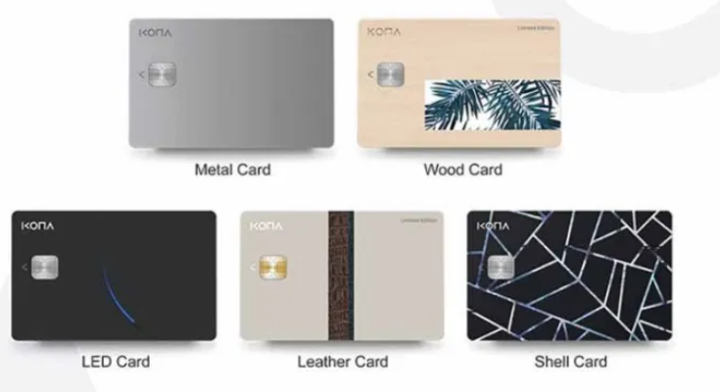

Figure-1: different types of smart cards

Ref: https://fintechbd.com/the-evolution-of-cards-in-bangladesh-market/

KONA I provides smart IC chips to the financial, telecommunication and public sector along with its security modules. It supplies smart cards such as metal card, gold card, eco-friendly card, LED card, PVC card, leather card, e cozen card etc. and KONA also supplies electronic cards such as fingerprint card, display OTP / Dynamic CVV card etc.

### 2.2.2 Payment platform

The KONA payment platform is an integrated marketing platform that combines payment systems with marketing services for customer relations. It allows its partner to build their own payment system with minimal cost and investment. Card types are:

* KONA Card
* KONA Benefits Card
* KONA Affiliate Card

People can use rechargeable Kona cards and businesses can have their customized cards like benefit cards and their own brand card which is called affiliate card.

### 2.2.3 Local Community Platform

* Local Currency
* Local Community Service

Local currency is a currency created based on consensus among community members and can only be paid within the region. Kona provides a local currency type card that uses 56 local governments across the country. Local community services include local currency based food delivery, taxi call service, local molls, voting service etc. Users can get benefits by discount, coupons, cashback etc.

### 2.2.4 Mobility Platform

KONA I has been researching on core technologies for big data and mobility platform to provide mobility service such as:

* Delivery Service
* Taxi Call Service

These services enrich local community life and local residents.

### 2.2.5 Block chain Platform

* Kona Chain: Kona Chain is an enterprise block chain platform solution based on hyper ledger Fabric.
* Deep Service: Deep service is based on block chain technology, it protects user personal information, so that user can freely express his opinions. Transparency and security of the results are guaranteed.

### 2.2.6 IoT platform

Three types of IoT (Internet of Things) service KONA currently have.

* KONA DM & FOLTA: using the DM & FOTA global standard it is possible to combine many kinds of devices including mobile phones. This system provides a real-time secure and autonomous IoT platform.
* KONA Things Platform: It is an open API (Application Programming Interface) based IoT platform. It ensures scalability.
* KONA AMI Platform: AMI (Advance Metering Interface) is energy oriented IoT platform that provides remote meter reading, facility and data management.

### 2.2.7 Data Platform

KONA I has been running over the past 20 years and it has a big collection of private and public data with various forms such as cards and finance. This data contributes to enriching KONA I's platform service. This data-based infrastructure provides various services such as real estate value information and issuance of various certificates.

### 2.2.8 Healthcare Platform

KONA health is a digital healthcare service and its "AI Health Q'' shows the correlation between symptoms and diseases based on an AI algorithm. It also has a hospital, pharmacy recommendation system and customized health product shopping mall.

## 2.3 Business Wings

KONA I has international sales offices and technical centers in almost 40 countries across the world such as in the United States, China, India and Bangladesh as well as local offices in Nigeria and Brazil. KONA I's global network is the driving force capable of swift responding to the demand of the global markets. Some of the countries are listed below:

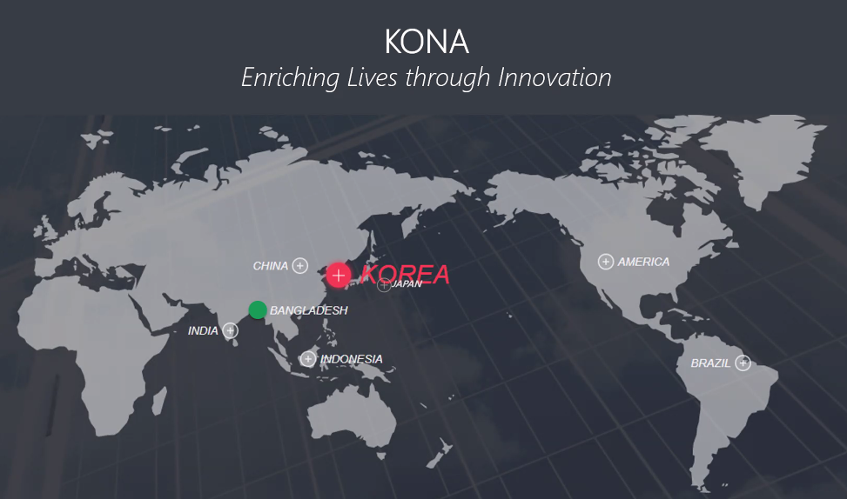

Figure-2: KSL business wings across the world.

# 3. Company Profile(KONASL)

—-------------------------------------------------------

—-------------------------------------------------

## 3.1 Introduction

Kona Software Lab Ltd.(KSL) was founded in 2012. Since then KSL has been working as the R & D center and global solution business wing of KONA which has over 22 years of dominant international presence. Currently KSL consists of 120+ employees. It is located at the beautiful place at Hatirjheel Bridge, Gulshan-1. With its location, employee’s friendly behavior, enough hardware and internet facilities, food and entertainment makes its environments productive. It provides various business and security solutions as well as digital platforms. The notable business solutions are Nexus Pay and Nagad.

## 3.2 Company History

KSL history starts from 2012 when it started its journey. Since then KSL has gone through many changes and stages. This section discussed some of those stages briefly.

* 2012: KSL established as an R & D center of KONA I Co. Ltd.
* 2013: Formation of Payment Lab and Security Lab.
* 2014:
  1. Inception of Solution Business to conduct the sales and marketing activities of the solutions and platform products of the company.
  2. Developed Public Key Infrastructure (PKI) based products such as Middleware, Certificate Authority, Secure Mail with Digital Signature, Secure File Transfer and so on.
  3. Development of a Cloud-based Contactless Payment Platform based on the specification of international payment brands- VISA, MasterCard.
* 2015
  1. Participated in Mobile World Congress in Barcelona, Spain to showcase the product of the company.
  2. Launched Kona Pay Digitalization Platform in Seoul, South Korea.
  3. Contract with the Transaction Security division of underwriters Laboratories, Singapore.
  4. Partnership with Thales UK Limited.
* 2016
  1. Successfully migrated the MULTOS card platform of Dutch Bangla Bank Limited to Java card platform.
  2. Contract with Dutch-Bangla Bank Limited to deploy the first-ever Cloud-based Contactless payment platform in Bangladesh.
* 2017
  1. Deploy Nexus Pay, the Host Card Emulation (HCE) based digital mobile wallet solution for Dutch-Bangla Bank Limited.
  2. Piloted QR-based payment at the cafeteria of Bank Asia Limited.
* 2018
  1. Deploy the Digital Financial Service Platform (product of Bangladesh Post Office, Nagad) for Third Wave Technologies Limited(TWTL)
  2. Registered the Tokenization module of Kona Pay Digitalization Platform with EMVCo as Token Service Provider.

## 3.3 Governing body

I would like to introduce honorable three persons from whole governing body of KSL.

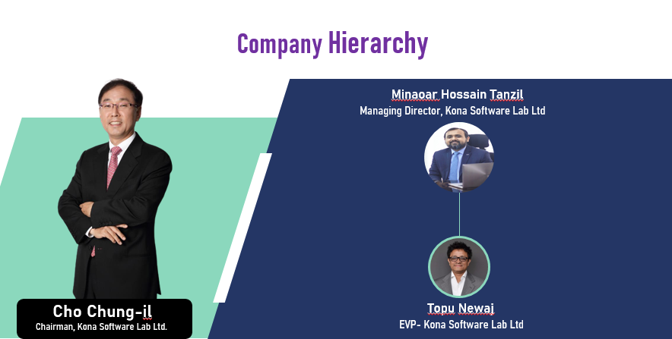

Figure-3: Honorable persons of KSL

Cho Chung-il from Korea positioned as Chairman of KSL, Minoar Hossain Tanzil and Topu Newaj are from Bangladesh positioned as Managing Director and Executive Vice President respectively. Full organization chart given below.

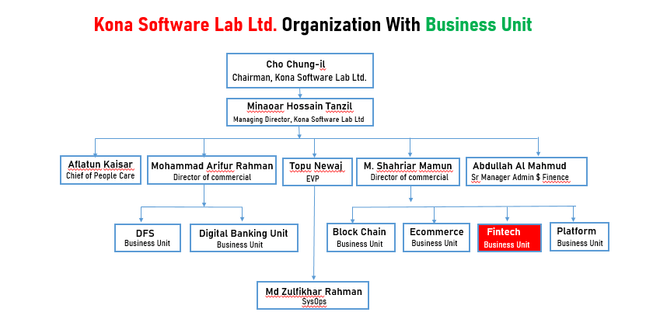

Figure-4: Organization structure of KSL

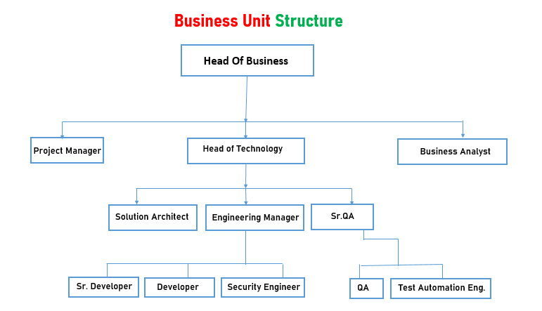

Figure-5: Business unit structure of KSL

## 3.3.1 Chairman Message

Hello, this is Cho Chung-il, Chairman of Kona Software Lab Ltd., and CEO of KONA I Co., Ltd. Since its establishment in 1998, KONA I has walked the path of aspiration and innovation. By developing and commercializing the nation’s first-ever bus-subway integrated transportation card system, we have changed the paradigm of public transportation use and entered the smart card business through an internally developed chip operating system(COS), currently supplying IC chips and smart cards to more than 90 countries worldwide. Based on the outcome, KONA I has solidified itself as Korea’s leading FinTechCompany that offers a total solution in the areas of payment, authentication, and security. Refusing to stop there, KONA I took on a new challenge, launching the “KONA CARD”, the nation’s first-ever rechargeable IC card that can be used for payments nationwide, in 2017. The process of developing the KONA CARD platform was a long journey of over5 years, not only following the EMV(international payment standard) standards but also enabling issuance, approval, payment, and clearing/settlement of cards. With the KONACARD, we have entered the card service business for general users, our first B2C business. Through benefits and services that are more innovative than any other card products, the KONA CARD is creating a change in card lifestyles, not only by leading the latest trends of emphasis on practical benefits but also based on its advantage of being able to form planned consumption habits. Affiliate companies led by KONA I are also promoting various unprecedented businesses. From Veaver E&T in charge of Veaver, a video knowledge sharing platform for companies, to art mining with expertise in the artist promotion business, they continue to secure new business areas and produce remarkable outcomes. KONA Group will continue to create synergy through active cooperation among affiliates. Amidst a fiercely competitive environment, history and past performance of a company are no longer valid, and companies that do not find new growth engines on their own cannot help but fall behind. Taking on new challenges and securing new capabilities based on generation-leading insight, flexible thinking, and fast execution are what enabled KONA I to reach their current status even through a countless hardships. Under the foundational spirit of benefiting the world with technology, KONA I will continue to focus on launching new technologies and services, and aim to become a global platform corporation beyond a mere Fintech company. We ask for your interests and support for our continuous aspirations and innovation.



Cho Chung-il

Chairman, Kona Software Lab Ltd.

## 3.3.2 MD Message

Back in 2012 when KONA SL was established, it was a small research and development center of the South Korean smart card industry pioneer KONA I Co., Ltd., mainly targeted to assist the parent company with developing the products and solutions for international market. Within couple of years we went through a major shifting and started a whole new wing to operate the global solution business activities managed from the Bangladesh office. We came a long way since then. Our Bangladesh office has played a vital role in conceptualizing, designing and developing the flagship of the company—an open and international standards compliant cloud-based payment platform—and it eventually shaped the parent company and its goals and strategies in the global market. This has been a humble effort from KONA SL to enhance synergy with its headquarters, create a positive impact on overall business and reputation of the company, and take it forward. This has all been possible for an excellent team of young, energetic and highly enthusiastic workforce with big appetite for self-improvement. They are our strength, our support system. It is such a blessing and quite refreshing seeing them fully aligned with the company vision and philosophies. Our other source of courage and support is the clients we are serving, especially here in Bangladesh. We are always moved by the dreams and aspirations of each of them, and the challenges they face to turn those into reality strike us hard. We feel, as a specialized payment and security company based in Bangladesh, it is our solemn responsibility no matter what to support them and accompany them in that inspiring journey toward transformation. To our immense pride and pleasure, we transformed the socioeconomic status of the country with NexusPay and Nagad. We are very positive that more of such big waves is destined to keep coming. We are one a kind, being the only multinational smart card and payments companies having direct presence in Bangladesh and working with the state-of-the-art technologies in the industry. I just want to reassure all our reputable clients that we are here to serve and we will continue expanding our areas of support and business with new innovations, and make more meaningful contributions in the payment and security industry in Bangladesh, as well as the rest of the world.

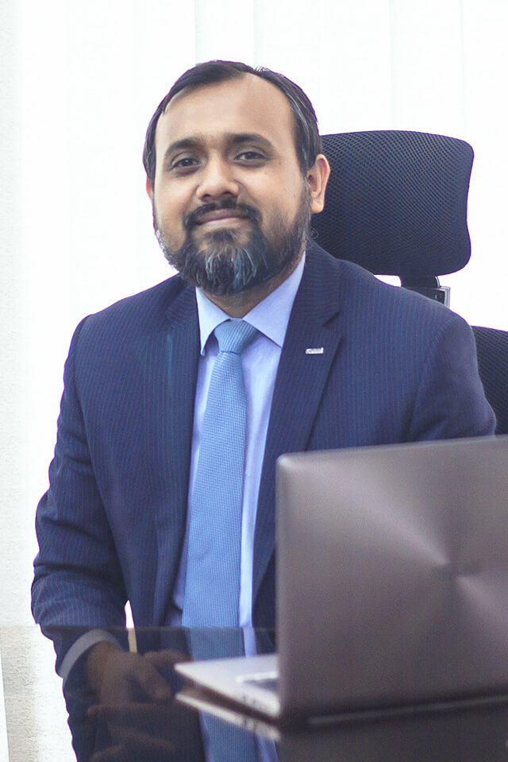

Minaoar Hossain Tanzil

Managing Director, Kona Software Lab Ltd.

## 3.4 Tech Stack

KSL is currently working on many projects as described in section 3.5, products and solutions.

Different technologies, frameworks and languages are being used here for different projects. Java as a Object Oriented Programming (OOP) language along with spring boot framework being used here almost all projects as backend applications tool. Raw JavaScript, JQuery library, Angular, React are also used for frontend development. Latest HTML (Hyper Text Markup Language) and CSS-3 are used for web page rendering and styling respectively. Be beep, Microsoft teams, Microsoft outlook, Gitlab, Git, Jira, Wiki sites are some of the frequently used tools in KSL.

## 3.5 Products & Solutions

### 3.5.1 Digitization Platform

* Kona Pay: Kona Pay digitization platform can digitize any payment and non-payment card as well as account (Bank card, Bank Account, Mobile Money Account etc.)
* Kona Card: This platform includes everything needed to run a card payment service on a single platform from the issuance of a card to the approval and settlement of transactions.
* Kona DFS: Kona Digital Financial Services (DFS) is a mobile phone-based financial services that is quite easy to avail and has board accessibility.

### 3.5.2 Smart Card and Personalization

Financial institutions need payment methods that are convenient and secure at the same time. Kona I offers various solutions sought by financial institutions at a reasonable price. So Kona I provides 5 services in this area.

1. EMV( International Payment Standard) card issuance product.
2. K-CPS(Kona Card Perso System) IC card issuance solution
3. K-IIS(Kona Instant Issuance Service) card issuance solution.
4. K-EVT is another solution with the advantage of checking correctness of data.
5. K-ECVS highly secured electronic card solution.

### 3.5.3 Security Solution

Government and public organizations need stronger security solutions to protect misuses of any official certificates and documents. Kona I's IC based ID card and relevant solutions (Health Card, E passport, International Driving License) meet all the security requirements.

### 3.5.4 IoT Platform Service

IoT platform uses DM & FOTA solution that applies to all devices including mobile creating unique value. It has enhanced security, All device support, real-time connection, open API and device update support. Home IoT and Things Platform are two major platforms based on IoT.

### 3.5.5 Enterprise Solution

* Veaver: video based knowledge sharing service. This platform uses company videos that replace traditional document based working environments. It helps to manufacture, regenerate and share companies' valuable information assets and knowledge in an easier and safer manner with videos.

## 3.6 Life at KSL (Company environment and culture)

KSL considers the contribution of its people as the fuel of their innovation. Company respects countries' rules and culture. They observe every special day with nice decorations, special foods and events. Here, in this section some facilities are listed.

### 3.6.1 Learning and Professional Growth Opportunity

Kona SL is an ample opportunity for learning and professional growth. Every fresher who joins KSL must go through some learning process. Some latest technologies are a new concern at KSL including micro service, block chain, and IoT. To ensure fresher’s have basic knowledge about those technologies, experienced developers at KSL take sessions on this topic. They provide assignments and after submission evaluation takes place. Besides attending these compulsory sessions, there are some optional topics such as security, git are presented by experienced developers. Anyone can join it and enrich their knowledge in that field.

### 3.6.2 Monthly Team Outing Allowance

A monthly allowance is given to all employees' of KSL considering their motivation for team building other than official works. This allowance is called team bonding allowance. The amount is BDT 1200 per month per employee. On a certain day fixed by the team leader they all go out to the nearest place such as a restaurant to spend this allowance money.

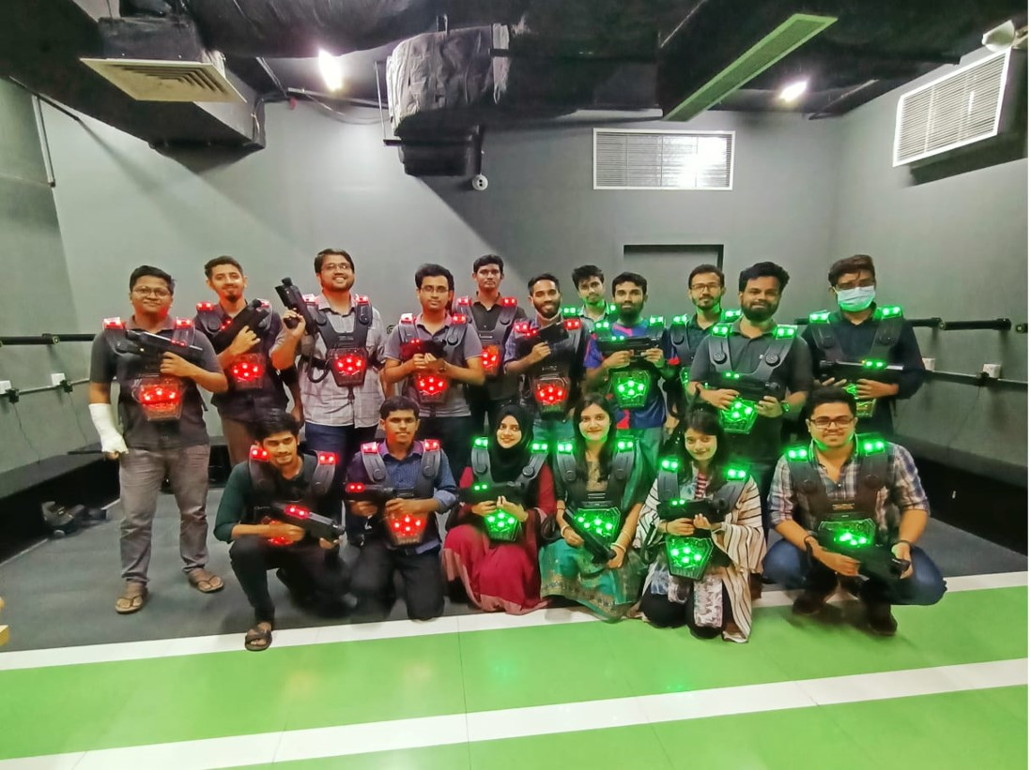

### 3.6.3 Annual Family Tour

An annual family tour is arranged to enrich and refresh KSLian’s minds. This tour takes place in some cool places in Bangladesh. It takes two or three days to complete this tour. During the tour all the employees stayed in a festive mood.

### 3.6.4 Holidays and Paid Leave

* Weekly holidays: All Saturday and Sunday are treated as weekly holidays. However, different holidays are also applicable for employees providing service on roaster.
* Public holidays: All the gazette holidays declared by the government of Bangladesh are treated as the official holidays of Kona SL.
* Leave: All the employees of KSL are entitled for 16 days' total leave in each English calendar year with full pay with the approval of immediate superior and departmental head. This paid leave will not include weekly and public holidays.
* Sick leave: An employee may apply for sick leave only when he is sick and unable to attend work. KSL has the provision of 14 days' Sick leave in a year. For prolonged illness, an employee can avail additional sick leave if it is needed.
* Maternity leave: A female employee is granted maternity leave for a period of 120 days.
* Paternity leave: A male employee also can avail paternity leave for a period of 5 working days.
* Awarded leave: If any employee works more than total hours in a month, s/he will be awarded annual leave against per 8 working hours'.
* Leave without pay: leave without pay may be granted to an employee in special circumstances when no other leave is available as entitlement.

### 3.6.5 Transport Facilities

KSL provides transport facilities to all its employees'. Transport systems are provided in different routes. The official transportation timing is fixed. Entry time is 8:30 and exit time is 6:30.

### 3.6.6 Breakfast Lunch and Snacks

KSL provides complimentary breakfast between 8:30 to 9:30. It also provides subsidiary lunch between 12:30 to 2:30. In the evening KSL provides snacks. An employee can avail dinner if s/he stays in the office till 10 PM.

### 3.6.7 Sports & Entertainment

Every day, after 5 PM KSLian engage themselves playing indoor game table tennis.

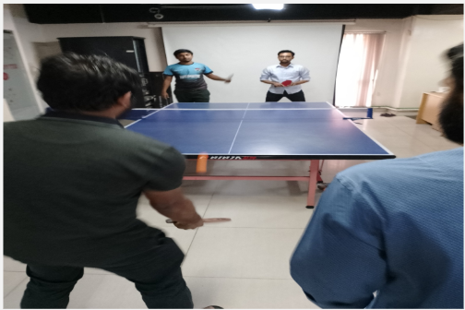

Figure-7: playing table tennis

There is also a PlayStation where employees can enjoy playing various games such FIFA, Mortal Kombat, Need For Speed etc. KSL also attend intercompany cricket and football tournaments.

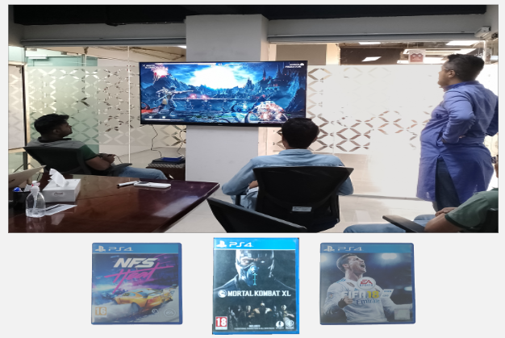

Figure-8: PlayStation

### 3.6.8 Dinning and Prayer Room

Dining room is located at the old office of KONA buffet lunch is served to the employees with variations. Prayer room is also available in office premise.

### 3.6.8 Sprint Planning

As mentioned above each team is closely managed by one Engineering manager. As KONA follows agile software development process, development phases are divided into sprints. Normally sprints contain two weeks that is 10 working days. At the starting of each sprint, development requirements are identified and development process is planned in presence of all team members. After that product engineering manager and team lead divide the sprint into small stories and breaks the small stories into tasks. Each task is assigned to individual team members and it is the duty of the team members to fulfill the task within given time schedule.

### 3.6.9 Daily Stand Up

At the starting of each working day daily stand up is hosted by engineering manager and all the team members are invited. The standup plays important role in development, as all team members clear their dependency of work with others. Each team member also needs to specify what he has done yesterday, what he will do today and if he needs any co-operation of other team members. As a result the whole team remains up to-date about the current status of their project and share their knowledge themselves.

### 3.6.10 Friendly Environment

I had almost done 6 months as an intern in Kona. All the members did no differentiate us with other employees. All the members are very friendly. They help us to adapt with the new changes and challenges. And this friendly environment helps us to refresh our minds while working for hours.

### 3.6.11 Inspiration

The environment of KONA is really inspiring. Specially my team lead inspired me after each completion of every small task. This inspiration helps to become more focused to my work. Upper management also inspires the full team after successful client demos. Sometimes chief technical officer gives treat to the whole team and takes them to team event.

### 3.6.12 Facilities for Employees

High productivity of employee plays vital role in the economic development of an organization. Salary is only the hygiene factor of job satisfaction. Motivating factors influence the employee’s dedication towards his work. KONA provides various facilities to their employees –

### 3.6.13 Dedicated Workplace

Each employee is provided highly configured PC and laptop for development purpose and other staffs like notebooks, pen, first aid kits etc for their usage.

### 3.6.14 High Speed Internet

24 hour high speed internet facility is provided and all internal and external communication with clients and members are done through skype.

### 3.6.15 Domestic Environment

KONA is like a family of rock stars. They help each other not only in professional life but also in their personal life. Working here is fun and working for the company is individual’s responsibility.

### 3.6.16 Fun and Passion

All the employees are always connected with each other and share a special bond among them. Sometimes its about doing research and development, sometimes having errors in code, sometimes discovering new solutions to problems, sometimes planning for events or sometimes its just selfie time. Sometime for simple reason we enjoy our time .

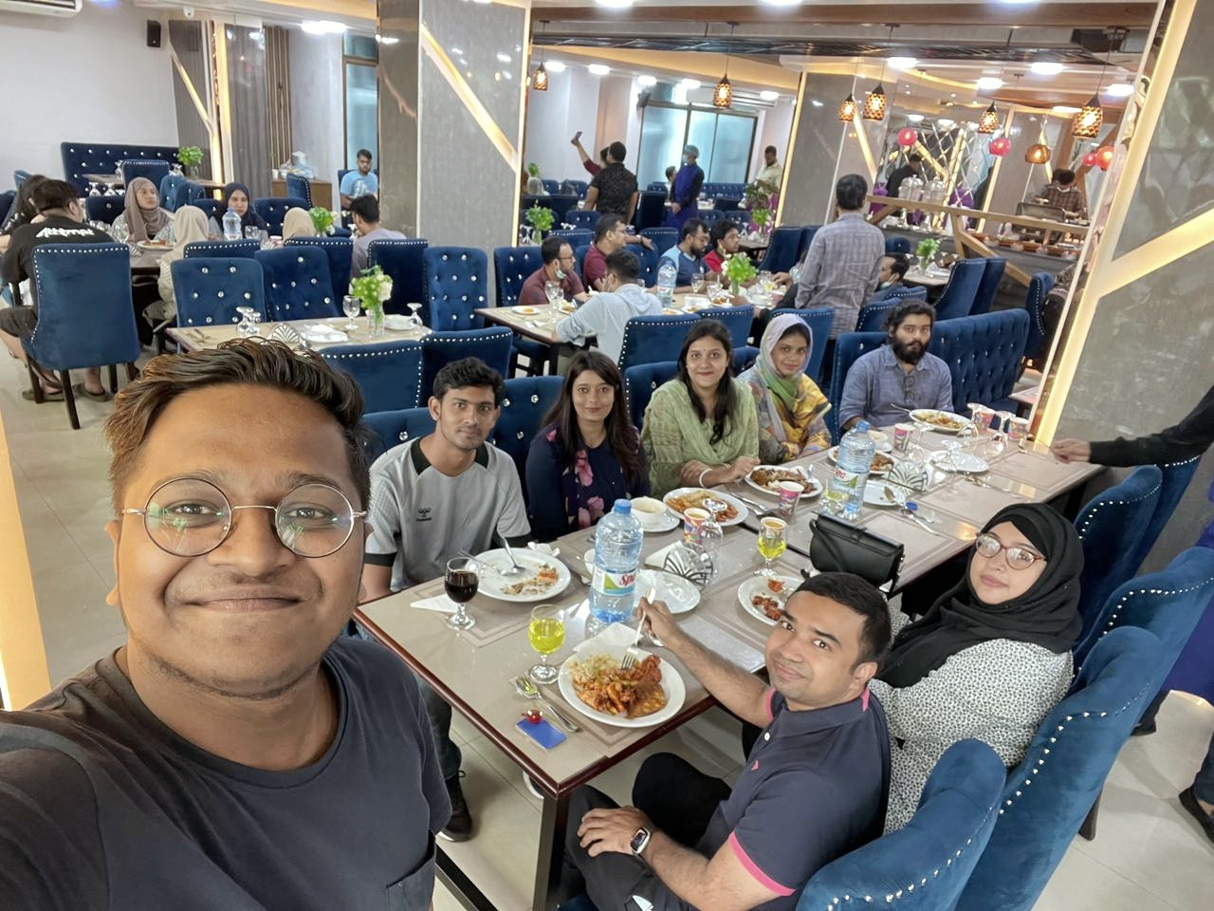

### 3.6.16 Good Bye Session and gift

All the members take part to buy gifts and surprise cards to wish any employee leaving the company. Sometimes they throw parties to say good bye. Everyone share his / her experience to work with me.

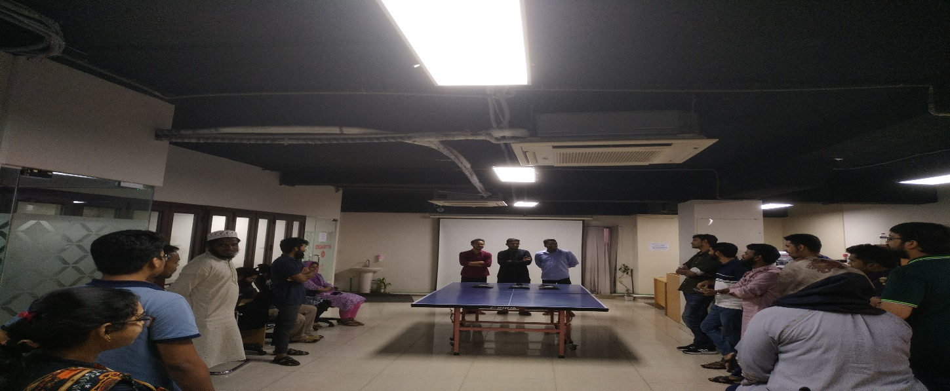

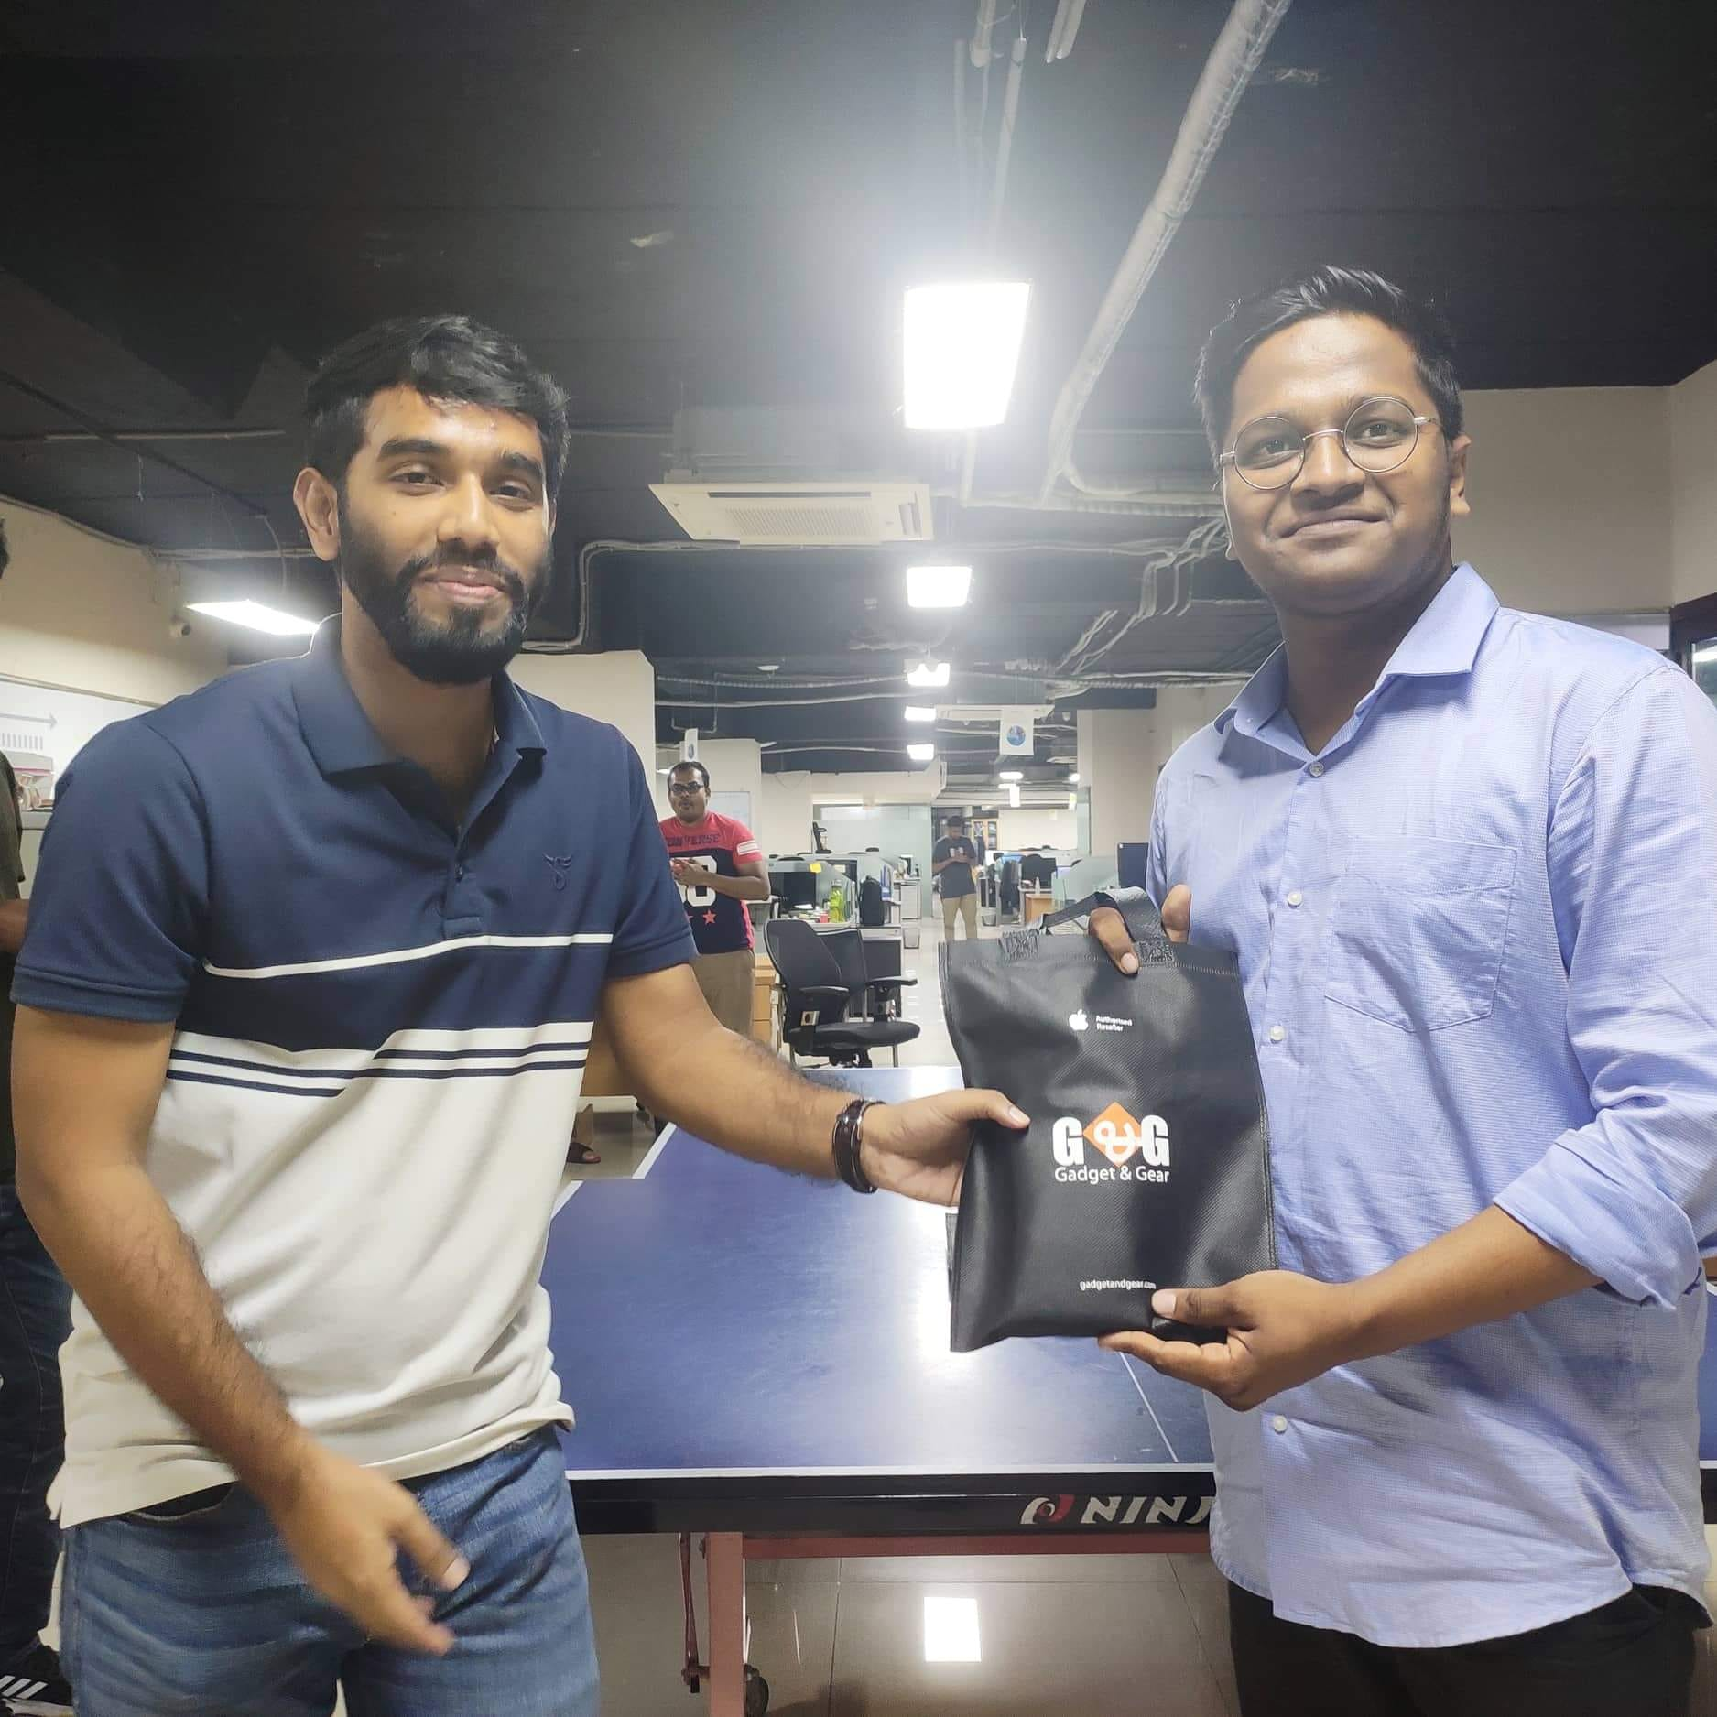

## 3.7 Departments

### 3.7.1 Admin

There is a dedicated admin department consisting of 8-10 employees. The Admin department works across all departments and all kinds of work.

* General Office Management
* Asset Management
* Transport Management
* Security and Safety Management
* Human resource Management
* Food Management
* Salary management
* Events management

These are some common tasks which are managed by the admin department.

### 3.7.2 IT support department

The IT support department maintains the computer networks within the company. This department provides technical support and ensures the whole company runs smoothly. New resource installment, Installing software, resolving network issues, setting up configuration etc. are maintained by the IT support department. Whenever an employee feels a technical issue with his computer he directly calls the IT support department by a software Microsoft Teams. In response to this call the IT support team resolves that issue physically or remotely whatever demands by the problem.

### 3.7.3 Development Department

Employees of this department are called developers. They directly write software code. This department is split into different teams such as block chain team, QA team, machine learning team etc. Scrum meetings are held every morning by each team. Every team is responsible for developing a specific software project by collaborating with the team members. Designing, coding, testing, releasing are some jobs done by developers.

## 3.8 Major Clients

From history, we learned that KSL deals with lots of products and solutions from its journey in 2012. Till now 2022 KSL identified all of its clients as shown in this picture below.

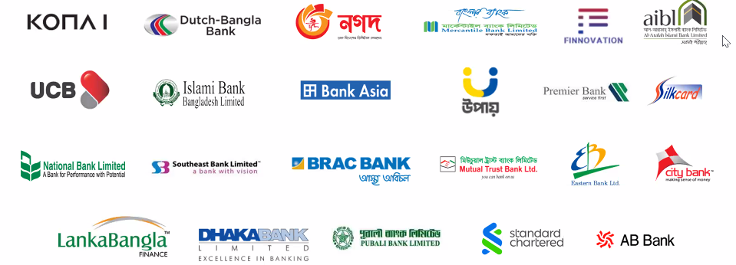

Figure-7: KSL major clients

## 3.9 Recruitment process

Fresher as well as experienced people can join KSL. Joining process is straightforward. People from different technologies are encouraged to submit an application. After primary screening applicants are called for some test process held at KSL premise.

1. Written Test: this test includes some basic questions such as OOP concept, Security, Database etc.
2. Hands-on Test: This test basically includes a programming test. Applicants are given some problems and expected to solve them using his convenient programming language.
3. Technical Viva
4. Final Viva

After successfully passing those tests one is eligible to have a joining offer.

# 4. Internship at KONASL

—-------------------------------------------------------

—-------------------------------------------------

## 4.1 Overview

In our academic life we complete courses on different technologies and concepts. Within this short time it is not possible to apply this knowledge with actual industry practices. Thus internship as part of academic curriculum plays a vital role in the learning phase of a student. As I joined KONASL as an intern, I had not proper knowledge about industry practices. KONASL employees helped me to overcome this situation by guidelines and making me familiar with new tools to manage the overall process.

## 4.2 First Day at Office

When I got my joining date, I was extremely glad, yet as the date came closer, I was somewhat

Apprehensive. Numerous inquiries involved my cerebrum like in what manner will be the air of

the workplace, will I have the capacity to modify with the associates, will I have the capacity to

function admirably and completer targets, and so on. I came in at about 9:00 am on the first day

and my supervisor welcomed me warmly, introduced me to my colleagues and team lead. He

showed me where my desk was and told me that he and my colleague would help me get started.

He was very helpful always and I sat next to him for the morning and just watched what he did. At lunch, HR and the staff of the office invited me to lunch. I was so nervous; I could hardly

eat a thing! We were gone for about 1-1.5 hours and just talked about the company, my studies,

etc. After lunch, Neom bhai (software engineer). Introduced me to everyone, showed prayer place, all that good stuff and me where the kitchen was, how the coffee machine worked, where the copy machine was. My day ended at 6.00pm. It was a great first day.

## 4.2 Appointment Letter

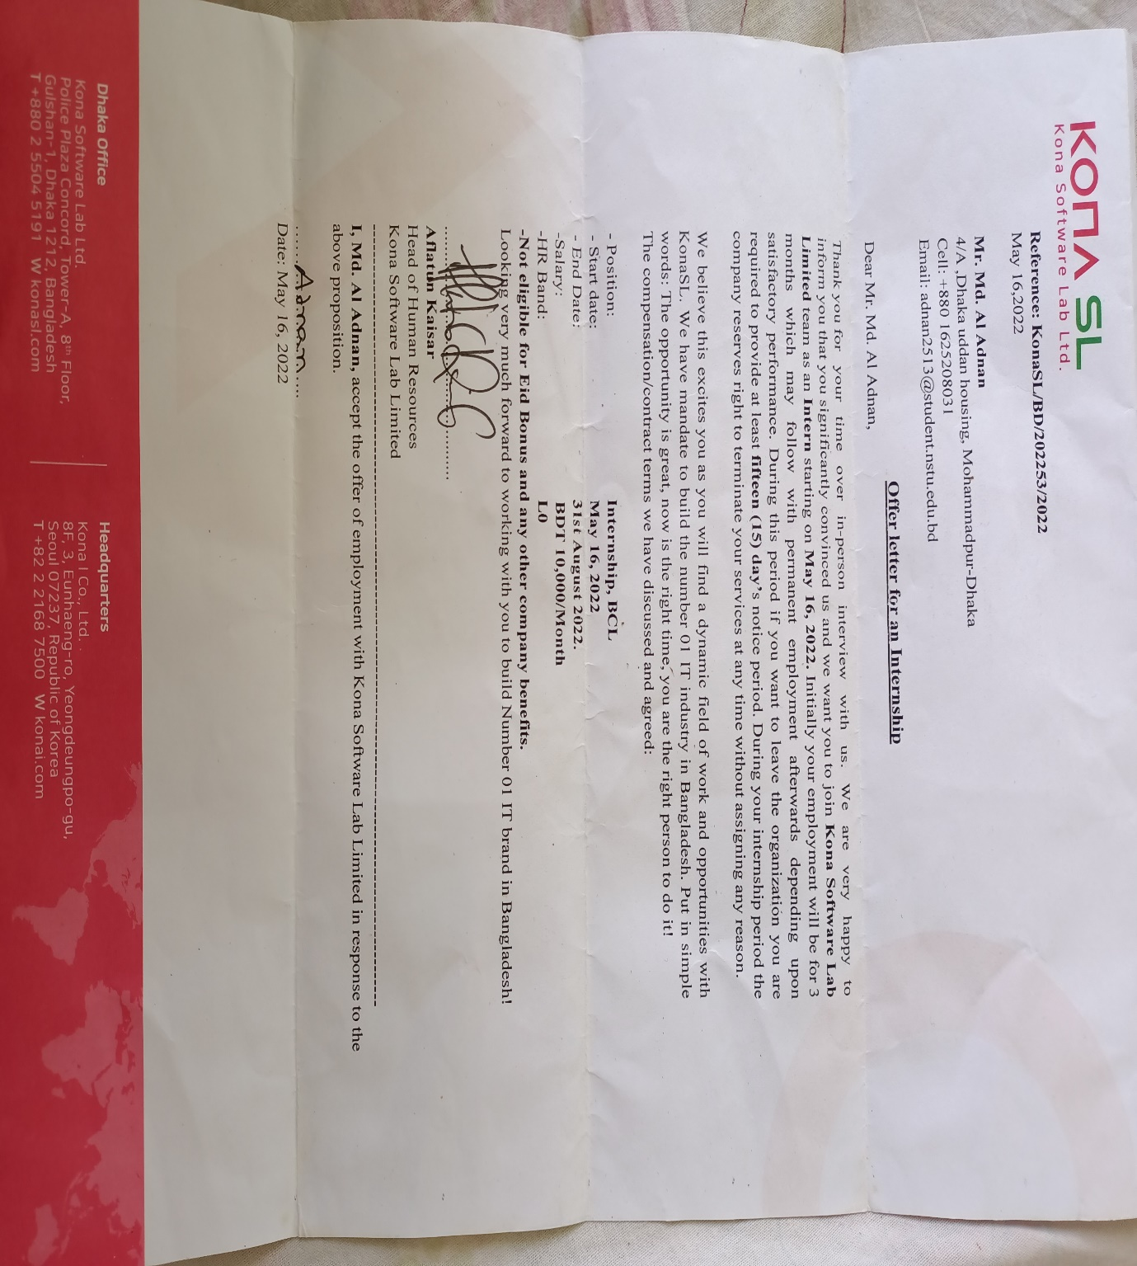

## 4.2.1 Internship Extension

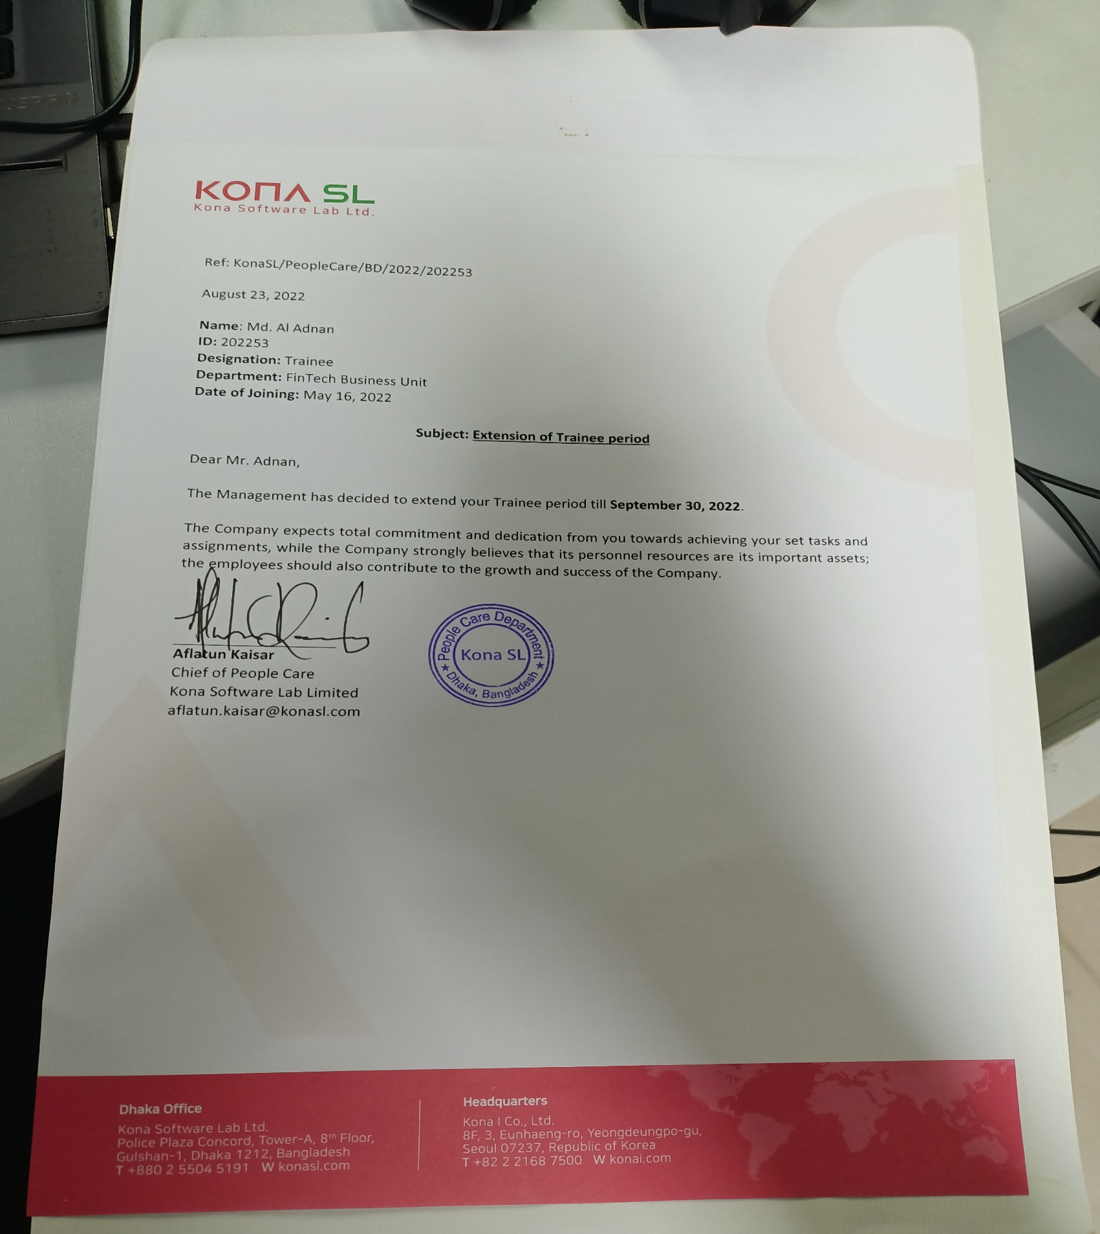

## 4.2.2 My desk

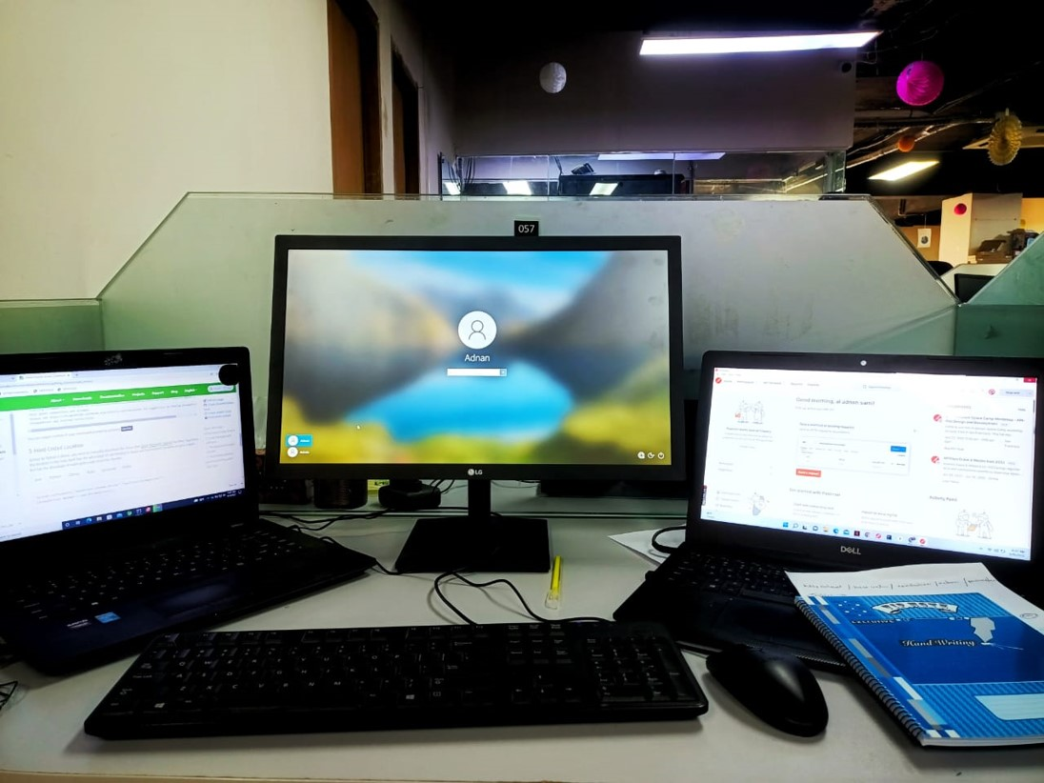

## 4.2.3 Facilities for Interns

All the members of KONA welcomed us just like any new employee. We were introduced to the other employees. We were treated just like any other employee of KONA. In the first stage we were in close observation of company HR and he shared his knowledge with us and spent his valuable time to make us comfortable with the environment.

Following are some of the facilities that we were offered in KONASL

* Dedicated workspace like any other employee
* Individual PC and other facilities
* Healthy amount of remuneration
* Opportunity to get familiar with new tools
* Opportunity to work in real life project
* Become a member of real life project team
* Flexible working time
* Flexible working environment

## 4.2.3 Conclusion

After spending five months of my internship program, I would really appreciate the provided facilities and knowledge of KONASL. The procedure they adopted for intern management is really impressive. I am also thankful to IIT foe giving me this chance.

# 5. P2P Cryptrade (An International Project)

—-------------------------------------------------------

—-------------------------------------------------

## 5.1 Project Description

Cryptrade is an online exchange platform where users can trade cryptocurrencies likes Bitcoin and etherum. Cryptrade provides a crypto wallet for traders to store their funds. Like other crypto exchanges, Cryptrade offers services like trading, sending coins, and receiving coins. Cryptrade has its own block chain-based token in its development phase named Kona coin.Users buy and sell cryptocurrencies though the website exchange of korean currency.

I joined Kona Software Lab Ltd. on 16 may 2022. After completing a one month introduction on spring boot ,Unit testing , Knowledge about automation and project structure I am considered as one of the resources of their project.

## 5.2 Technologies

The technologies used by this project are described here.

### 5.2.1 HTML

The Hypertext Markup Language or HTML is the standard markup language for displaying documents to web pages. HTML consists of a series of elements that describe the structure of a webpages. Elements just label a piece of content such as "this is h1 heading", " this is paragraph" etc. CSS and JS can be used to access HTML elements.

### 5.2.2 CSS

Cascading style sheets(CSS) is a styling sheet that is used to customize the HTML element's appearance. CSS selectors or inline CSS can be used to access and design HTML elements.

### 5.2.3 JavaScript

JavaScript, abbreviated as JS, is a programming language that is one of the core technologies of the world wide web, alongside HTML and CSS. It is a lightweight, interpreted, or just-in-time compiled programming language. In web JS is used providing functional behavior of documents. We can describe what will happen when a button is clicked, when mouse hover over a certain element, when keyboard starts typing etc. So JS makes the web page intractable, live. We can change CSS dynamically, request other sites bringing data, adding event handlers etc. The only limitation is our thinking ability.

### 5.2.4 Java

Java is a general-purpose programming language that is class-based and object-oriented. The programming language is structured in such a way that developers can write code anywhere and run it anywhere without worrying about the underlying computer architecture. It is also referred to as write once, run anywhere (WORA).

### 5.2.5 React

ReactJS is a declarative, efficient, and flexible JavaScript library for building reusable UI components. It is an open-source, component-based front end library which is responsible only for the view layer of the application. It was initially developed and maintained by Facebook and later used in its products like WhatsApp & Instagram.4.2.6 Gradle

Gradle is a build automation tool for multi language software development. Normally, after writing code we need to download dependency files, compile every class, link them together into a single file, adding resources and finally test and deploy code. Gradle automates this whole process. Gradle defines project structure such as where to write source classes, test classes, adding resources and provides a way describing required libraries. Gradle automatically download those dependency files, compile and build the project on behalf of developers. Developers just focus on coding.

## 5.3 Libraries And Frameworks

### 5.3.1 jQuery

jQuery is a lightweight library of JavaScript functions. jQuery is considered as a ‘write less, do more’ JavaScript library. It makes things easier when working with HTML document traversal and manipulation, event handling, animation, and Ajax. The best part of jQuery is that It works the same way regardless of browser types.

P2P uses JQuery instead of raw JavaScript for building all the front-end modules.

### 5.3.2 Spring Boot

Spring boot is an open source micro service-based Java web framework. Spring boot frameworks create a production-ready environment that is completely configurable with its pre-built code. Spring Boot uses spring security features that have built-in protection against common attacks. Spring provides an easy way of connecting and interacting with databases, creating REST APIs using MVC (Model View Controller) pattern. This is why the project uses Java and Spring Boot framework to develop its backend APIs. More about Spring Boot described in the next section.

### 5.3.3 Thymeleaf

Thyme leaf is a Java template engine for processing and creating HTML, XML, JavaScript, CSS and text.

It allows for natural templating, can do complex processing and lets us easily define custom dialects. On top of that, Thyme leaf facilitates the collaboration of both front end and back end developers on the same template file, greatly increasing productivity.

### 5.3.3 Toast UI Grid

The TOAST UI Grid is a component that can display, edit, add, and delete multiple data. The Grid is a powerful library with features like data editing, filtering, paging, sorting, and more, and can be used to customize the editor or the renderer to desired format.

### 5.3.4 TestNg

TestNG is a testing framework for the Java programming language. In p2p project automation we used selenium testNg framework, For report generate we use allure report.

## 5.4 Tools

### 5.4.1 Intellij IDEA

This project uses Intellij IDEA as an integrated development tool to get benefitted of its rich features. More about Intellij IDEA discussed in the next section.

### 5.4.2 GitLab

GitLab is a web based git repository. GitLab has an issue tracker and wiki for each project. GitLab contains a built-in DevOps tool which is used to build, test and deploy securely our project.

### 5.4.3 DataGrip ( The Cross-Platform IDE for Database)

DataGrip is a cross-platform Integrated development tool for database management. It is designed to query, create and manage databases. Location of the database can be a local or remote server. DataGrip supports MySQL, PostgreSQL, Oracle, Microsoft SQL server etc. DataGrip contains smart SQL editor editing queries. It can detect probable bugs in the database and suggest the best option to fix. DataGrip saves all the queries runed previously and provides a way to navigate history.

### 5.4.4 Git

Git is a free and open source version control system. Git widely used software to track changes, coordinating work amongst programmers. Git has built-in GUI, gitk and git bash. Its goals include speed, data integrity and non linear workflows.

### 5.4.5 Jmeter

For load testing p2p used Jmeter.

# 6. My Contribution

—-------------------------------------------------------

—-------------------------------------------------

## 6.1 Problem Statement of Project

In my learning phase I was working with internal projects assigned by company Head of Technology for making strong base for future development. I was assigned in a real life project named p2p. Because of large scale project it was a laborious task to test the full project. That’s why company felt the necessity to build up an automation tool to automate the full testing process.

## 6.1.1 My Responsibility

**My job description (role):** Software Automation Engineer.

* My daily activities was to improve automation added new automation field as per as developer needed
* Writing code for new feature and existing feature so than developer and SQA team can save their time.
* We Develop three version of automation testing tool.

1. (General) First of all write Selenium (TestNg) code for running our code in happy path than refactor the code.
2. (Excel Based) Secondly work with excel sheet automation where sheet are used to perform automation testing.
3. (Dynamic) Thirdly fully backend project where automation is run by calling api (using postman).

## 6.1.2 Team

In automation team we had three members Rahat Uddin Azad, Anwar Kabir Sajib and me. Also we had 22 others team member from developer, tester and engineering manager.

## 6.1.3 Tools & Technology

Following are the tools that I used while performing the above mentioned responsibilities:

* Selenium
* Excel
* Anum Processor
* Test Parram
* Data aggregator
* VS Code
* Intellij IDEA

## 6.1.4 Challenges

* New Framework & Technology Learning(Like Spring boot, selenium TestNG , Data Aggregator, Allure Report)
* Maintaining large codebase.
* Structured Coding
* Coding without dependency

## 6.2 Problem Statement of Project

To estimate how many users can hit the application at a time we needed to do the load test.

## 6.2.1 My Responsibility

* Test the actual load for specific API
* Test the actual load for p2p users

## 6.2.2 Team

I did the load test all by myself. And I generate the report and submitted to Ruhit Bhai using Jira.

## 6.2.3 Tools

* JMETER

## 6.2.4 Challenges

* New Framework & Technology Learning(Like Jmeter & Html Report)

## 6.2.4 Conclusion

I learnt a lot through this time as I learnt new Framework and Technologies.

# 7. My Team Outing

—-------------------------------------------------------

—-------------------------------------------------

## 7.1 Introduction

KONASL offers monthly team outing for its employees .It is a mean of increasing collaboration, cooperation and creating healthy environment among its employees. P2P team was very energetic and hardworking.

## 7.2 Team outing at TOGGI FUN WORLD

In Toggi Fun World it was my first team outing with my P2P team. Here we done some exciting gaming activities.



## 7.3 Team outing at FANTASY KINGDOM

In Fantasy Kingdom it was my second team outing with my P2P team. Here we done some exciting gaming activities like santa maria, roller coster, Magic carpet.

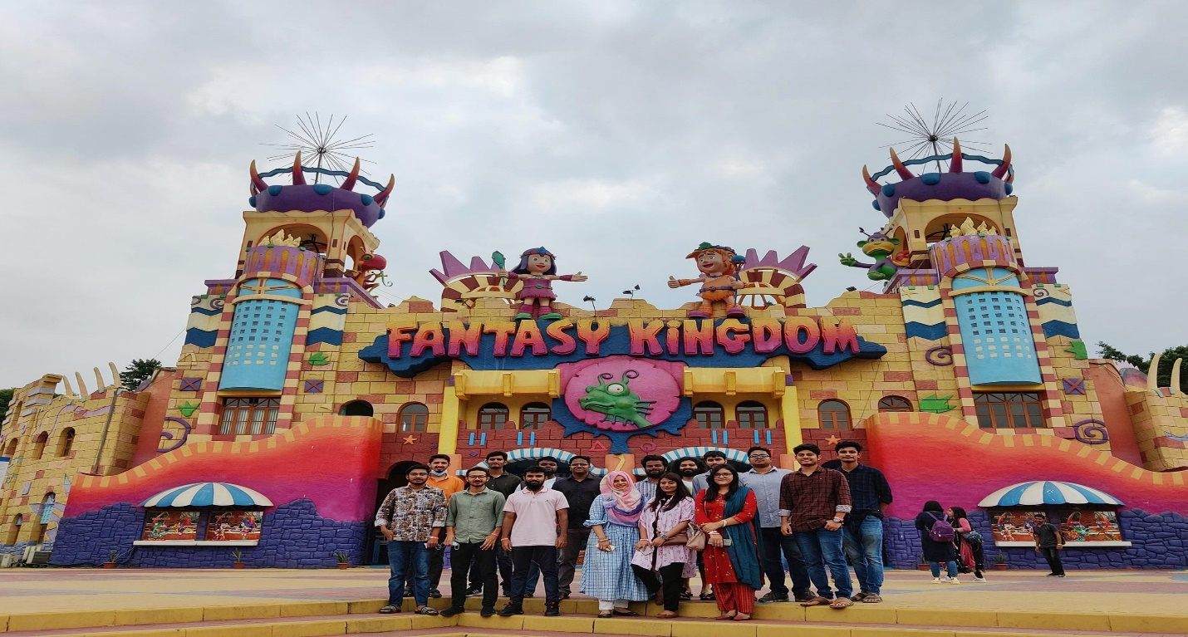

## 7.4 Team outing at YAMCHA DISTRICT

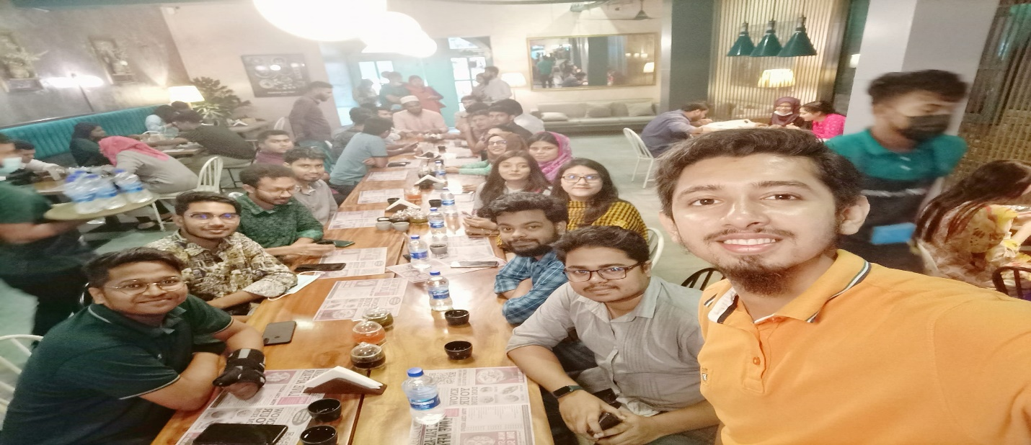

## 7.5 Team outing at CAFÉ-RIO

In this picture we can see my team lead, head of business, business analyst, SQA team and Manager.



# 8. Technical and Professional Growth

—-------------------------------------------------------

—-------------------------------------------------

## 8.1 Technologies and tools I Learned

* Automation Testing In Selenium
* Spring Boot( JPA, JDBC, annotations, etc)
* Jira Task Management
* Log status read
* JMETER
* Postman
* React Basic
* Allure Report
* Website automation in different ways
* GitHub
* GitLab
* Visual Studio
* JavaScript
* HTML, CSS

## 8.2 Professional skill I Learned

## 8.2.1 Development Technique

As a fresher when I started my development tasks I had a lots of confusions and questions. But as I mentioned KONASL follows agile process, whenever we get new challenges we have some buffer time to do some research and development activities. Our team lead and seniors are always there to influence our development skills. Daily scrum helps me to get up-to-date with the new technologies and the current status of the project. As the project is huge and everyone works in different modules, one does not have detail idea about another module. So knowledge sharing sessions are arranged among the team members.

## 8.2.2 Project Deployment

After every two weeks code would be merged and then deploy to QA server

## 8.2.3 No bullying and blaming

Software development is always a team work. And when there is a team work, misunderstanding is very usual. However, I have never seen my team leaders and project managers to bully people working under their supervision. Personally, I have made a lot of mistakes last in five months. But my project manager had never been harsh with me. Blaming others for their mistakes does not solve the problem. It only makes the situation and the relationship between coworkers worse. My team lead always encouraged me in case of success and helped me to fix the problems in case of any failure.

## 8.2.4 Respect for Each Other

In a corporate environment respect for each other is a must. For gaining respect a person need to show respect to his fellow co-workers. Doing this creates a healthy environment among the members and a helping hand of seniors is always there for you.

## 8.2.5 Attitude

As an intern the attitude of my seniors attract me very much and I always try to follow them to be a successful Software Engineer as well as a successful man. They always know what to say and how to say, what is the right time for decision making or a change. Their entire attitude towards their profession, team members and most important their work influenced me a lot.

## 8.2.6 Planning

Planning at the starting of a day is a professional practice. I have seen all my seniors start their day by planning all their tasks for that specific day. My team lead always emphasizes us to resolve our blocking issues with one another at the starting of the day. It helps us to be stick to our sprint planning activities.

## 8.2.7 Attendance and punctuality

Punctuality is another important issue in professional life. Every person need to attend the meetings on the exact time. At every scrum meeting go to office before 9 am.

# 9. Self-Assessment

—-------------------------------------------------------

—-------------------------------------------------

In the following part I will represent my viewpoint on my achievements as an intern. I will assess my abilities that I gained and nourish through my internship program. As part of intern evaluation a form was sent to KONASL which is fill up by my supervisors. I would assess myself on the base of those skills.

|  |  |  |  |  |  |  |
| --- | --- | --- | --- | --- | --- | --- |
|  | Outstanding  (5) | Very Good  (4) | Average  (3) | Needs Improvement  (2) | Poor  (1) | Sub-Total |
| 1. Punctuality  Attends work regularly and on time | √ |  |  |  |  | 5 |
| 2. Ability to Solve Problems  Skill and Duration to resolve issues |  | √ |  |  |  | 4 |
| 3. Accuracy of Work  To be accurate and precise at work | √ |  |  |  |  | 5 |
| 4. Creativity  How much ingenuity you have shown in work |  | √ |  |  |  | 4 |
| 5. Dedication  Produces the expected volume of work in scheduled time | √ |  |  |  |  | 5 |
| 6. Professionalism  Conduct, behavior and attitude at work or business environment | √ |  |  |  |  | 5 |
| 7. Team Work  Cope-up ability with team along with work distribution and helplines with others | √ |  |  |  |  | 5 |
| 8. Growth of New Technology  How frequent and adaptive in learning new tactics and technologies | √ |  |  |  |  | 5 |
| 9. Interpersonal Communication  Maintains effective two-way communication with staff, peers and supervisor | √ |  |  |  |  | 5 |
| 10. Leadership Skill  Takes initiative on project assignments and offers effective solutions for improving operations |  | √ |  |  |  | 4 |
| TOTAL  (out of 50) | | | | | | 47 |

# 10. Conclusion

—---------------------------------------

—--------------------------------

It completed five months since my joining at KSL since 16-may-2022 to 30-September. I remember the very first day at KSL, the HR department took us to every lab and we were introduced as the youngest employees at KSL. Afterwards, Aflatun Kaisar, Chief of People Care, Kona Software Lab Ltd., told us that they do not expect too much from us. We should maintain office time, learn the environment & culture and enjoy other facilities. They keep their words throughout those five months. I never feel pressure by them or my project manager, Md. saiful Islam, Head of Technology, Kona Software Lab Limited. Again my cordial respect for them.

I joined a real project, P2P. This project was managed by Headquarter, Korea. We went through many discussions with them over online to get a clear understanding about what we are going to develop. Requirements changed many times and we, the team members, changed our codebase accordingly. Implementing changes is always hard. After every release we got a great relief. To refresh our mind we used to go out for tea, outings and small tour.

Those activities helped us develop friendship and communication. I have learned many technologies, frameworks, libraries, tools and concepts that enriched my knowledge. I am successfully accustomed to professional company culture. I had a very good time at KSL.

Internship is undoubtedly an important program of BSSE that will help one to proceed towards the future with confidence.

# 11. References

[1] KONA I website “<https://konai.com/>” [last accessed 30-september-2022

[2] Kona Software Lab Limited “<https://konasl.com/>” [last accessed 28-may-2022]

[3] Veaver Information “<https://www.veaver.com/>” [last accessed 1-june-2022]

[4] Spring boot “<https://spring.io/projects/spring-boot>” [last accessed 2-june-2022]

[5] Security Architecture “<https://docs.spring.io/spring-security/reference/servlet/architecture.html> [3-june-2022]